**LABORATORY PROGRAM – 8**

Write a program which creates two threads, one thread displaying “BMS College of Engineering” once every ten seconds and another displaying “CSE” once every two seconds.

**OBSERVATION :**

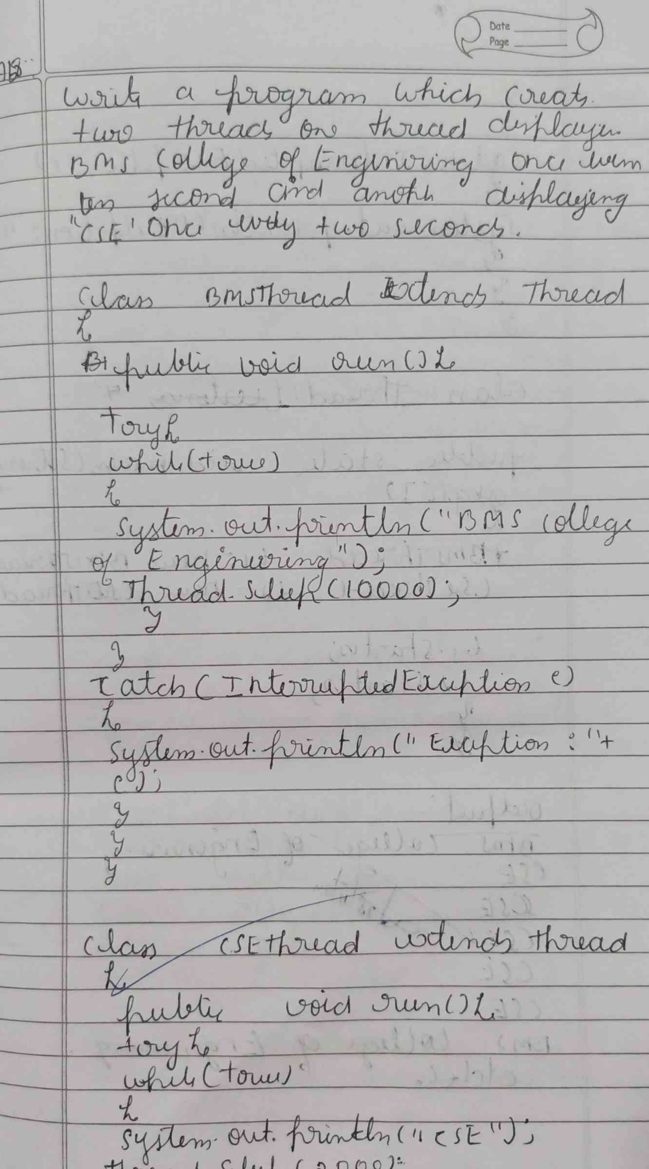

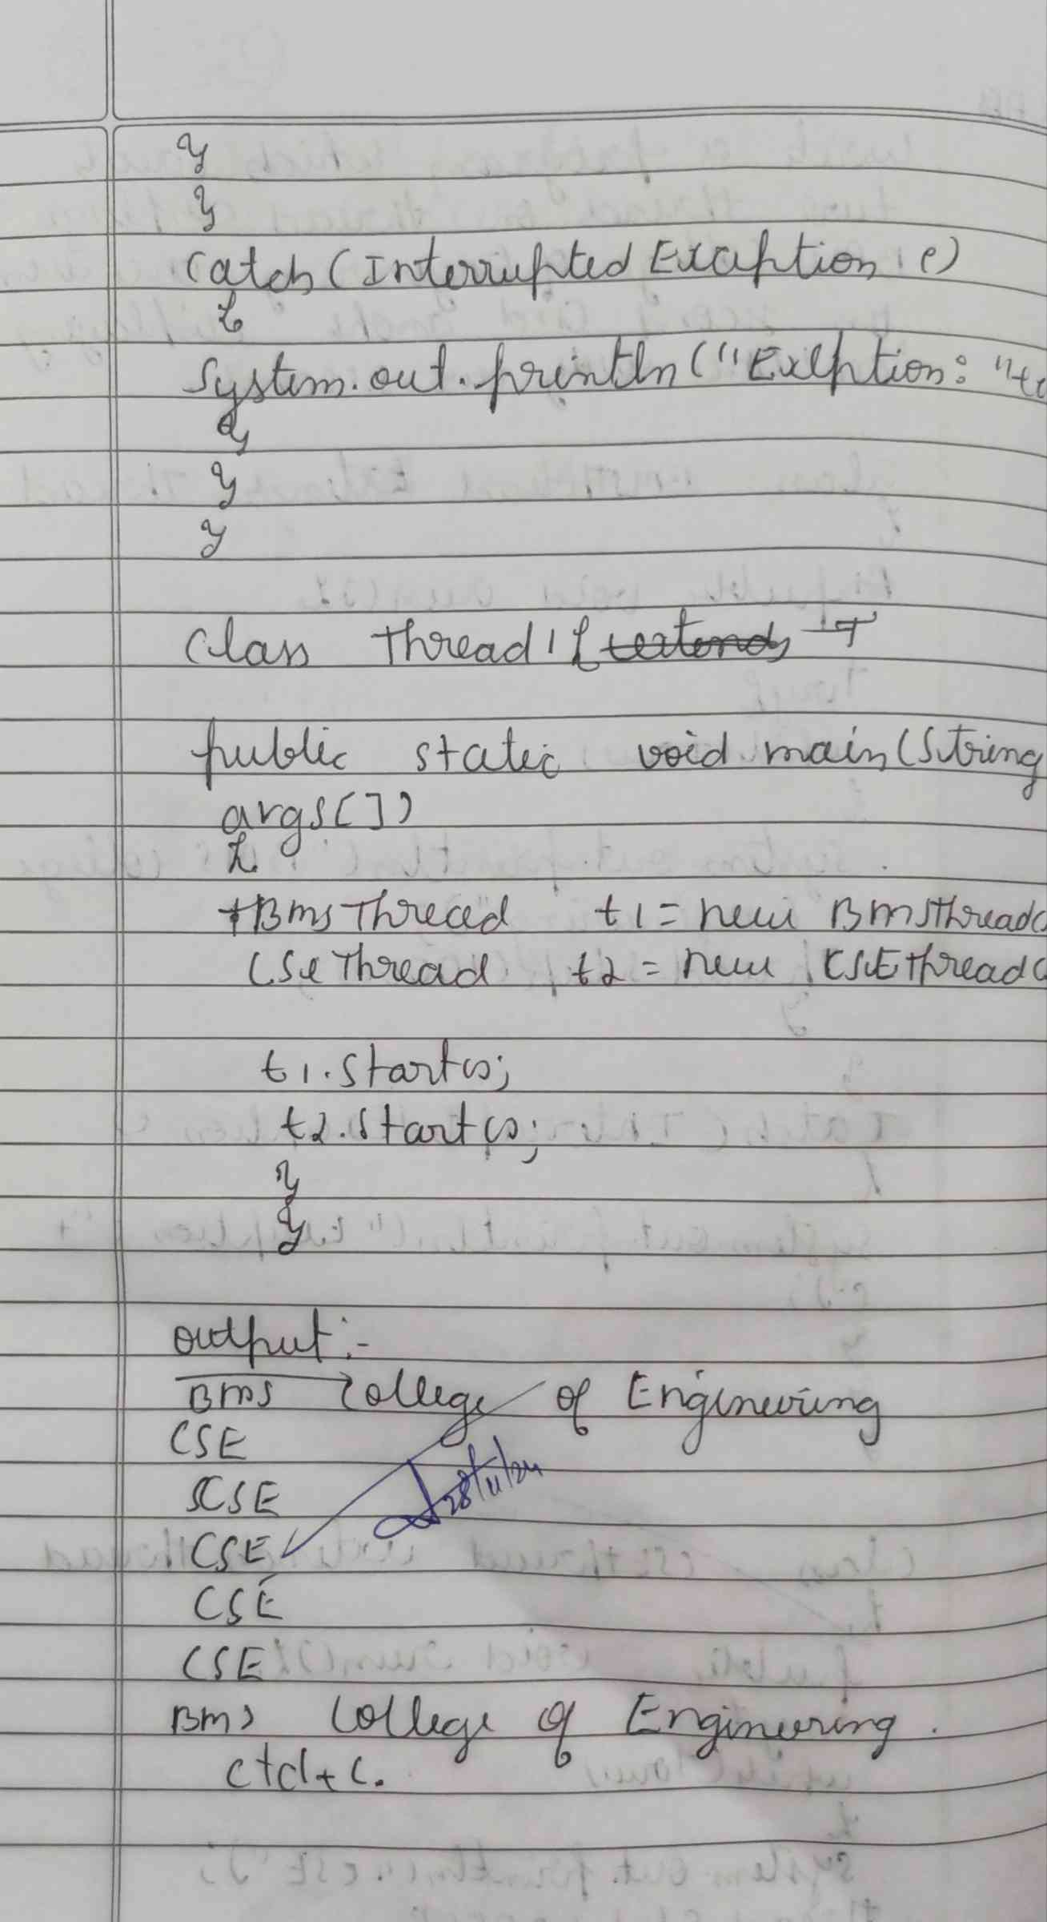

**CODE :**

**class BmsThread extends Thread{**

**public void run(){**

**try{**

**while (true) {**

**System.out.println("BMS college of Engineering");**

**Thread.sleep(10000);**

**}**

**}catch(InterruptedException e){**

**System.out.println(e);**

**}**

**}**

**}**

**class CseThread implements Runnable{**

**Thread t;**

**public void run(){**

**try{**

**while (true) {**

**System.out.println("Cse");**

**Thread.sleep(2000);**

**}**

**}catch(InterruptedException e){**

**System.out.println(e);**

**}**

**}**

**}**

**public class DemoThread  {**

**public static void main(String[] args) {**

**BmsThread b=new BmsThread();**

**Runnable cse=new CseThread();**

**Thread t1=new Thread(cse);**

**b.start();**

**t1.start();;**

**}**

**}**

**OUTPUT :**

